./

GENESIS – Advanced Python Programming



|  |  |  |  |  |  |
| --- | --- | --- | --- | --- | --- |
| **Ver. Rel. No.** | **Release Date** | **Prepared. By** | **Reviewed By** | **To be Approved** | **Remarks/Revision Details** |
| 1.0 | 11/12/2020 | Lakshmi N |  | Srinivas K |  |
| 1.1 | 12/12/2020 | Lakshmi N |  | Srinivas K |  |
|  |  |  |  |  |  |
|  |  |  |  |  |  |
|  |  |  |  |  |  |

**Details**

# **CURRENCY CONVERTER**

**Table of Contents**

ACTIVITY 1 4

1 PYTHON CODE 4

2 PEP8 SCREENSHOT 8

3 INPUT FILE SCREENSHOT 8

4 OUTPUT FILE SCREENSHOT 9

ACTIVITY 2 10

5 OOPS CONCEPT 10

6 PEP8 SCREENSHOT 15

**List of Figures**

Figure 1: PEP8 SCREENSHOT 7

Figure 2: INPUT FILE SCREENSHOT 8

Figure 3: OUTPUT FILE SCREENSHOT 8

# ACTIVITY 1

# PYTHON CODE

# Currency Converter

# Value of 1 USD = 76.65 INR

usd = 76.65

# Value of 1 EURO = 789.52 INR

euro = 89.52

# Set to 1 when file is being written

file_handling_flag = 0

# USD to INR conversion

class usd_inr:

USD = 0.0

def conversion(self, amount):

USD = amount*usd

if(file_handling_flag == 0):

print("The amount in INR is: ", "{0:.2f}".format(USD))

else:

test_obj1 = input_output_file()

test_obj1. testing_write("USD", "INR", amount,

"{0:.2f}".format(USD))

# INR to USD conversion

class inr_usd:

INR = 0.0

def conversion(self, amount):

INR = amount/usd

# print("The amount in USD is: ",INR)

if(file_handling_flag == 0):

print("The amount in USD is: ", "{0:.2f}".format(INR))

else:

test_obj1 = input_output_file()

test_obj1.testing_write("INR", "USD", amount,

"{0:.2f}".format(INR))

# EURO to INR conversion

class euro_inr:

EURO = 0.0

def conversion(self, amount):

EURO = amount*euro

# print("The amount in INR is: ",EURO)

if(file_handling_flag == 0):

print("The amount in INR is: ", "{0:.2f}".format(EURO))

else:

test_obj1 = input_output_file()

test_obj1.testing_write("EURO", "INR", amount,

"{0:.2f}".format(EURO))

# INR to EURO conversion

class inr_euro:

INR = 0.0

def conversion(self, amount):

INR = amount/euro

# print("The amount in EURO is: ",INR)

if(file_handling_flag == 0):

print("The amount in EURO is: ", "{0:.2f}".format(INR))

else:

test_obj1 = input_output_file()

test_obj1.testing_write("INR", "EURO", amount,

"{0:.2f}".format(INR))

# File Handling for testing

class input_output_file:

def testing_read(self):

fr = open("inputfile.txt", "r")

for line in fr:

option = int(line[0])

value = ''

for i in range(2, len(line)):

value = value + line[i]

value = float(value)

menu(option, value)

fr.close()

def testing_write(self, curr1, curr2, given_value, conv_value):

fw = open("outputfile.txt", "a")

output_str = str(str(given_value) + " " + curr1 + " --> " +

curr2 + " " + str(conv_value) + "\n")

fw.write(output_str)

fw.close()

# Menu function

def menu(x, amount):

if (x == 1):

obj = usd_inr()

obj.conversion(amount)

elif (x == 2):

obj = inr_usd()

obj.conversion(amount)

elif (x == 3):

obj = euro_inr()

obj.conversion(amount)

elif (x == 4):

obj = inr_euro()

obj.conversion(amount)

elif (x > 5):

print("Invalid choice !!!")

print(" \t\t\tCURRENCY CONVERTER \n\n")

print("Options:")

print("\t1. USD ---> INR")

print("\t2. INR ---> USD")

print("\t3. EURO ---> INR")

print("\t4. INR ---> EURO")

print("\t5. Testing file handling")

value = int(input("Enter your choice "))

if(value < 5):

amount = float(input("Enter amount to be converted: "))

menu(value, amount)

if(value == 5):

test_obj = input_output_file()

file_handling_flag = 1

test_obj.testing_read()

print("\noutputfile.txt updated using inputs from inputfile.txt\n")

# PEP8 SCREENSHOT

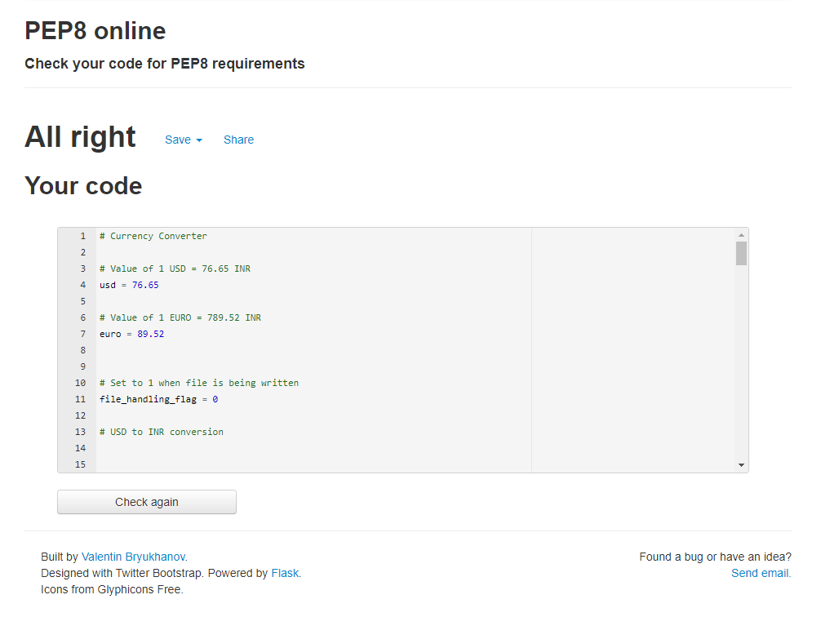

Figure 1: PEP8 SCREENSHOT

# INPUT FILE SCREENSHOT

* 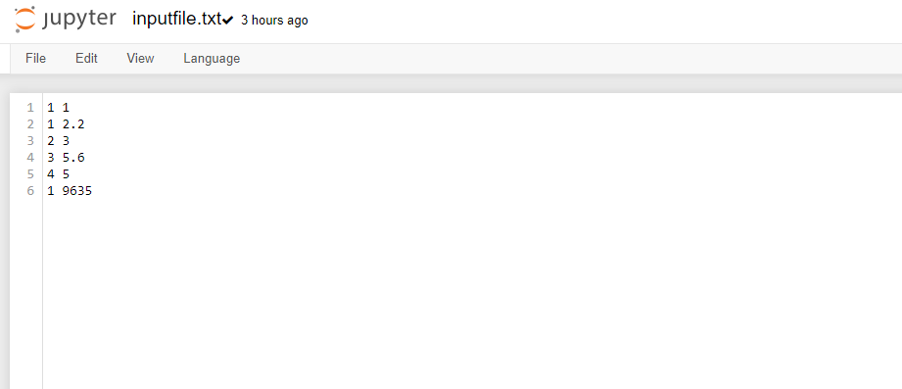Enter the choice as 5 to check the file handling.

Figure 2: INPUT FILE SCREENSHOT

# OUTPUT FILE SCREENSHOT

Figure 3: OUTPUT FILE SCREENSHOT

# ACTIVITY 2

# OOPS CONCEPT

# Currency Converter

import requests

url = str.__add__('http://data.fixer.io/api/latest?access_key=',

'5934bf3f2adef071c95f87d808b3bb28')

class CurrencyConverter:

# empty dict to store the conversion rates

rates = {}

def __init__(self, url):

data = requests.get(url).json()

self.rates = data["rates"]

def convert(self, from_currency, to_currency, amount):

if from_currency != 'EUR':

amount = amount / self.rates[from_currency]

# limiting the precision to 2 decimal places

amount = round(amount * self.rates[to_currency], 2)

return amount

# Set to 1 when file is being written

file_handling_flag = 0

# USD to INR conversion

class usd_inr(CurrencyConverter):

def __init__(self, x):

super().__init__(url)

self.x = self.convert("USD", "INR", 1)

def conversion(self, amount):

try:

assert amount > 0

USD = amount * self.x

if(file_handling_flag == 0):

print("The amount in INR is: ", "{0:.2f}".format(USD))

else:

test_obj1 = input_output_file()

test_obj1. testing_write("USD", "INR", amount,

"{0:.2f}".format(USD))

except AssertionError:

print("Invalid input")

# INR to USD conversion

class inr_usd(usd_inr):

def conversion(self, amount):

try:

assert amount > 0

INR = amount/self.x

if(file_handling_flag == 0):

print("The amount in USD is: ", "{0:.2f}".format(INR))

else:

test_obj1 = input_output_file()

test_obj1.testing_write("INR", "USD", amount,

"{0:.2f}".format(INR))

except AssertionError:

print("Invalid input")

# EURO to INR conversion

class euro_inr(CurrencyConverter):

def __init__(self, x):

super().__init__(url)

self.x = self.convert("EUR", "INR", 1)

def conversion(self, amount):

try:

assert amount > 0

EURO = amount*self.x

if(file_handling_flag == 0):

print("The amount in INR is: ", "{0:.2f}".format(EURO))

else:

test_obj1 = input_output_file()

test_obj1.testing_write("EURO", "INR", amount,

"{0:.2f}".format(EURO))

except AssertionError:

print("Invalid input")

# INR to EURO conversion

class inr_euro(euro_inr):

def conversion(self, amount):

try:

assert amount > 0

INR = amount/self.x

if(file_handling_flag == 0):

print("The amount in EURO is: ", "{0:.2f}".format(INR))

else:

test_obj1 = input_output_file()

test_obj1.testing_write("INR", "EURO", amount,

"{0:.2f}".format(INR))

except AssertionError:

print("Invalid input")

# EURO to USD conversion

class euro_usd(CurrencyConverter):

def __init__(self, x):

super().__init__(url)

self.x = self.convert("EUR", "USD", 1)

def conversion(self, amount):

try:

assert amount > 0

EURO = amount*self.x

if(file_handling_flag == 0):

print("The amount in USD is: ", "{0:.2f}".format(EURO))

else:

test_obj1 = input_output_file()

test_obj1.testing_write("EURO", "USD", amount,

"{0:.2f}".format(EURO))

except AssertionError:

print("Invalid input")

# USD to EURO conversion

class usd_euro(euro_usd):

def conversion(self, amount):

try:

assert amount > 0

USD = amount/self.x

if(file_handling_flag == 0):

print("The amount in EURO is: ", "{0:.2f}".format(USD))

else:

test_obj1 = input_output_file()

test_obj1.testing_write("USD", "EURO", amount,

"{0:.2f}".format(USD))

except AssertionError:

print("Invalid input")

# File Handling for testing

class input_output_file:

def testing_read(self):

fr = open("inputfile.txt", "r")

for line in fr:

option = int(line[0])

value = ''

for i in range(2, len(line)):

value = value + line[i]

value = float(value)

menu(option, value, url)

fr.close()

def testing_write(self, curr1, curr2, given_value, conv_value):

fw = open("outputfile.txt", "a")

output_str = str(str(given_value) + " " + curr1 + " --> " +

curr2 + " " + str(conv_value) + "\n")

fw.write(output_str)

fw.close()

# Menu function

def menu(x, amount, url):

if (x == 1):

obj = usd_inr(url)

obj.conversion(amount)

elif (x == 2):

obj = inr_usd(x)

obj.conversion(amount)

elif (x == 3):

obj = euro_inr(url)

obj.conversion(amount)

elif (x == 4):

obj = inr_euro(x)

obj.conversion(amount)

elif (x == 5):

obj = euro_usd(url)

obj.conversion(amount)

elif (x == 6):

obj = usd_euro(url)

obj.conversion(amount)

elif (x > 8):

print("Invalid choice !!!")

print(" \t\t\tCURRENCY CONVERTER \n\n")

print("Options:")

print("\t1. USD ---> INR")

print("\t2. INR ---> USD")

print("\t3. EURO ---> INR")

print("\t4. INR ---> EURO")

print("\t5. EURO ---> USD")

print("\t6. USD ---> EURO")

print("\t7. Testing file handling")

value = int(input("Enter your choice "))

if(value < 7):

amount = float(input("Enter amount to be converted: "))

menu(value, amount, url)

if(value == 7):

test_obj = input_output_file()

file_handling_flag = 1

test_obj.testing_read()

print("\noutputfile.txt updated using inputs from inputfile.txt\n")

# PEP8 SCREENSHOT

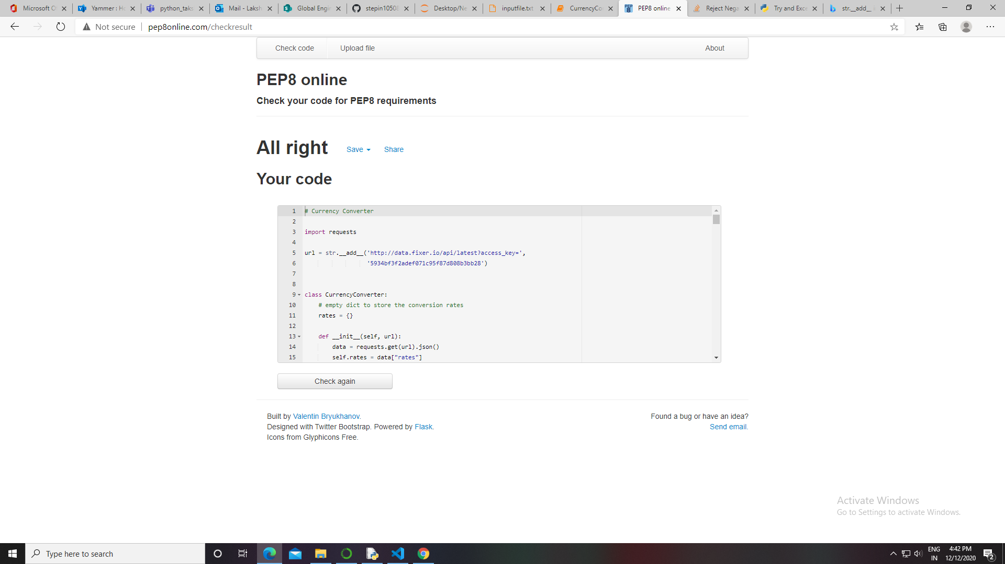

Figure 4: PEP8 SCREENSHOT-OOPS CONCEPT